## **Project “RPG Demo” 1.5-Page GDD**

*Diablo meets Monty Python*

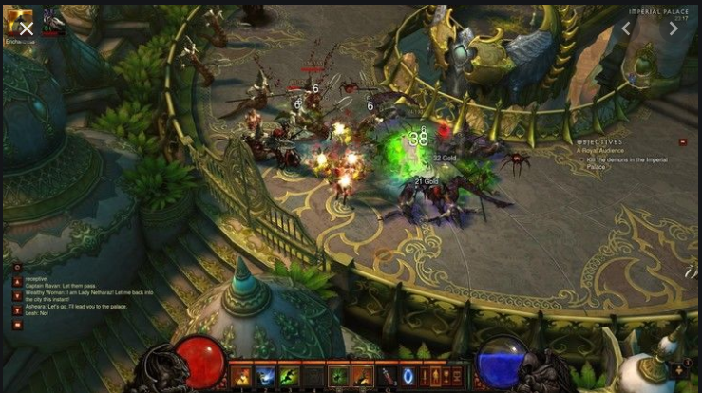

**Genre:** 3rd person action RPG, single player, fixed-camera  
**Target Audience:** 13+ (T for Teen) fans for old school RPGs like Diablo and people who like funny things

**Controls:** Mouse and keyboard

**Thematic Setting:** Medieval Europe / Fantasy / Knights and Swords and Dragons and stuff

**Tech Stack:** Unity 2018.3, Audacity, Asset store for 3D and UI

**Platform(s):** PC / Steam

**MVP Game Moment:**  2 minutes of simple linear level flow with basic combat against 3 or 4 enemy types.

**Game Summary:** Project “RPG Demo” is a Diablo style RPG with the absurd humour of Monty Python and the Holy Grail. The game is set during the grubby phase of medieval era when brave Sir Knights were bold and foolish and the unbathed peasants reeked of cabbage. As our unlikely elderly hero, you must battle the Queen’s solider and grotesque monsters by finding ancient weapons, leveling up your character, venturing to far off lands (using special “Wizerd magik” known as “meta-map fast-travel”), and seeking answers to the ultimate riddle – “Who am I and why are dragons such jerks?”

**Core Player Experience: Funny / The joy of laughter**

**Central Story Theme:** Unlikely hero

**Design Pillar:** Putting the player in absurd / funny / ridiculous situations.

**Remarkability:** Absurd humour – “The Dirt Old Hoe”

**Anticipated Steam Early Access Launch date:** Middle of 2020

**Feature Development Priorities:**

* **Real-time combat with tons of different enemies to smash**
* **All the required RPG abilities and stats (upgradeable)**
* **Level building and game progression**
* **Branching dialogue system**
* **Inventory, loot, usable items**

**Reference Games: Ember, BattleHeart: Legacy, Diablo, Torchlight 2**